Author : Peter Macharia

Email : [mpeter778@gmail.com](mailto:mpeter77@gmail.com)

**AI Development Workflow Assignment.**

### **Part 1:**

### **Breast Cancer Biopsy Image Classification.**

**Project Objective**

My primary goal is to develop a deep learning model for classifying histopathological breast cancer biopsy images from the BreakHis dataset as either benign or malignant. This project is driven by three core objectives:

1. To build a high-accuracy model for the automatic classification of breast tumor images.
2. To create a tool that assists pathologists by highlighting potentially malignant cases, thereby accelerating review.
3. To enable more consistent and rapid diagnosis, particularly in resource-limited environments.

The key stakeholders in this work are pathologists, diagnostic imaging specialists, and the breast cancer patients who rely on accurate and timely diagnoses. To measure success, I will use the **Validation F1-Score** as the key performance indicator (KPI), as it effectively balances precision and recall—a crucial requirement for minimizing false negatives (missed cancers) while controlling for false positives.

**Data and Preprocessing Strategy**

The project will utilize the **BreakHis dataset** from Kaggle, which contains 9,109 biopsy images at various magnification levels (40X to 400X), each labeled as benign or malignant. I will also leverage supplementary metadata from the image filenames, such as tumor subtype and patient ID, where available.

A significant risk in this dataset is **patient-level data leakage**. Since multiple images may exist for a single patient, a naive train-test split could lead the model to memorize patient-specific artifacts rather than generalizable pathological patterns.

To mitigate this and prepare the data, I will implement the following preprocessing steps:

1. **Patient-Wise Splitting:** I will ensure that all images from a single patient are confined to only one data set (training, validation, or testing).
2. **Image Resizing:** All images will be normalized to a standard size (e.g., 224x224 pixels) to be compatible with standard CNN architectures.
3. **Data Augmentation:** I will apply transformations such as flips, rotations, color jitter, and zoom to the training data. This artificially expands the dataset, improving the model's generalization capabilities and balancing class representation across different magnifications.

**Model Development and Evaluation**

I have selected a **Convolutional Neural Network (CNN)** as the model architecture, specifically a pretrained model like **ResNet50 or EfficientNetB0**. These models are ideal because they leverage transfer learning, which allows them to learn deep spatial features from high-resolution medical images even with a relatively small labeled dataset. Their strong performance in prior histopathology tasks makes them a reliable choice.

My data splitting strategy will be a **70% Training, 15% Validation, and 15% Test** split. This split will be performed by patient ID to prevent the data leakage mentioned earlier and will use stratified sampling to maintain a balanced benign-to-malignant ratio in each set.

During training, I will focus on tuning two critical hyperparameters:

1. **Learning Rate:** This is crucial for ensuring stable and efficient convergence.
2. **Batch Size:** This affects training stability and memory usage and will be tuned based on GPU constraints.

For evaluation, I will use two primary metrics:

1. **F1-Score:** As the main KPI, it balances the trade-off between sensitivity (recall) and specificity, which is essential in a high-stakes diagnostic task.
2. **AUC-ROC:** This metric measures the model's ability to distinguish between benign and malignant classes across all classification thresholds.

**Deployment and Monitoring**

A key post-deployment challenge is **concept drift**, where the characteristics of biopsy images might change over time due to new imaging technologies or tissue preparation techniques. To monitor this, we will periodically re-evaluate the model on new patient data and use statistical tests (like the KS Test) on image distributions to detect drift.

The primary technical challenge during deployment will be **high-resolution image processing**. The BreakHis images (700x460) are memory-intensive. Efficient handling during inference, possibly through techniques like image tiling, patching, or using lightweight CNNs, will be crucial for achieving the real-time performance needed for clinical use.

### **Part 2:**

### **Case Study - Predicting Hospital Readmission Risk.**

**Problem Scope**

In this case study, I will outline the development of an AI system to predict the likelihood of a patient being readmitted to the hospital within 30 days of discharge. The goal is to enable proactive interventions, reduce readmission rates, and improve patient outcomes.

The objectives are to:

* Achieve over 80% accuracy in identifying high-risk patients.
* Reduce 30-day readmission rates by 15-20%.
* Optimize the allocation of post-discharge care resources.
* Improve overall patient health outcomes and satisfaction.

The stakeholders for this system are broad, including primary stakeholders like patients and clinicians; secondary ones like hospital administrators and insurance companies; and tertiary ones such as regulatory bodies and community health organizations.

**Data and Preprocessing Pipeline**

A successful healthcare AI model depends on comprehensive and well-integrated data. My strategy involves collecting data from disparate sources, cleaning it, and engineering clinically meaningful features.

**Proposed Data Sources:**

1. **Electronic Health Records (EHRs):** Diagnoses (ICD-10 codes), procedures, lab results, vital signs, medications, and length of stay.
2. **Demographics & Social Determinants:** Age, gender, ethnicity, socioeconomic status, living situation, and distance from the hospital.
3. **Historical Data:** Previous admissions, emergency department visits, and outpatient follow-up compliance.

**Ethical Concerns:**

1. **Patient Privacy:** There is a risk of re-identification when combining datasets. Unauthorized access to sensitive health information must be prevented.
2. **Algorithmic Bias:** The model may underperform for underrepresented populations, potentially widening existing healthcare disparities.

**Preprocessing Pipeline Breakdown**

1. **Data Collection & Integration:** The first step is to merge data from multiple systems (EHR, LIS, pharmacy). We will use unique patient identifiers for matching and ensure temporal alignment, so that data from a previous admission is not incorrectly associated with the current one.

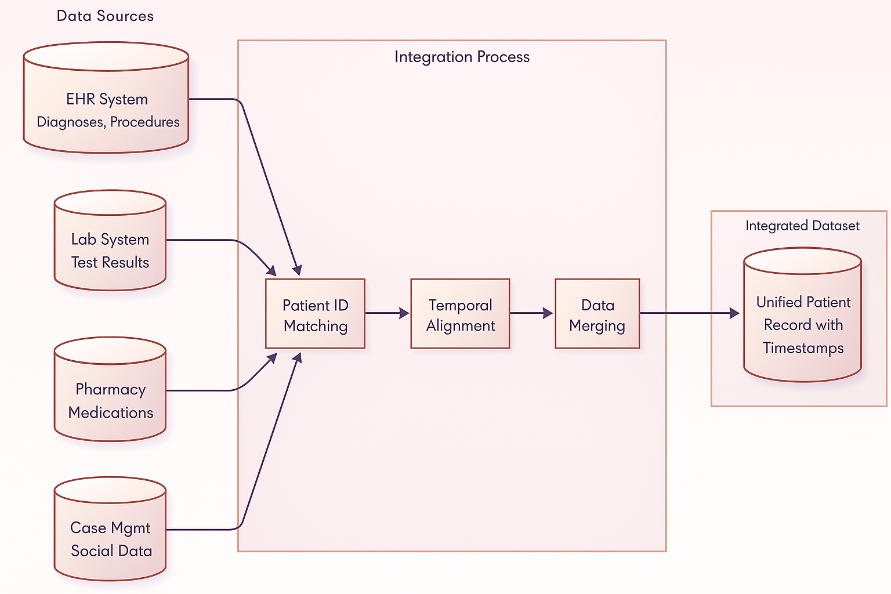

1. **Data Cleaning:** Healthcare data is notoriously messy. Missing values are often clinically meaningful (e.g., a missing HbA1c test may indicate a non-diabetic patient) and cannot be treated as random. We will use techniques like forward-fill imputation for short gaps in numerical data and flag longer gaps as separate features. We will also consolidate duplicate records and standardize formats (e.g., converting all dates to ISO format).

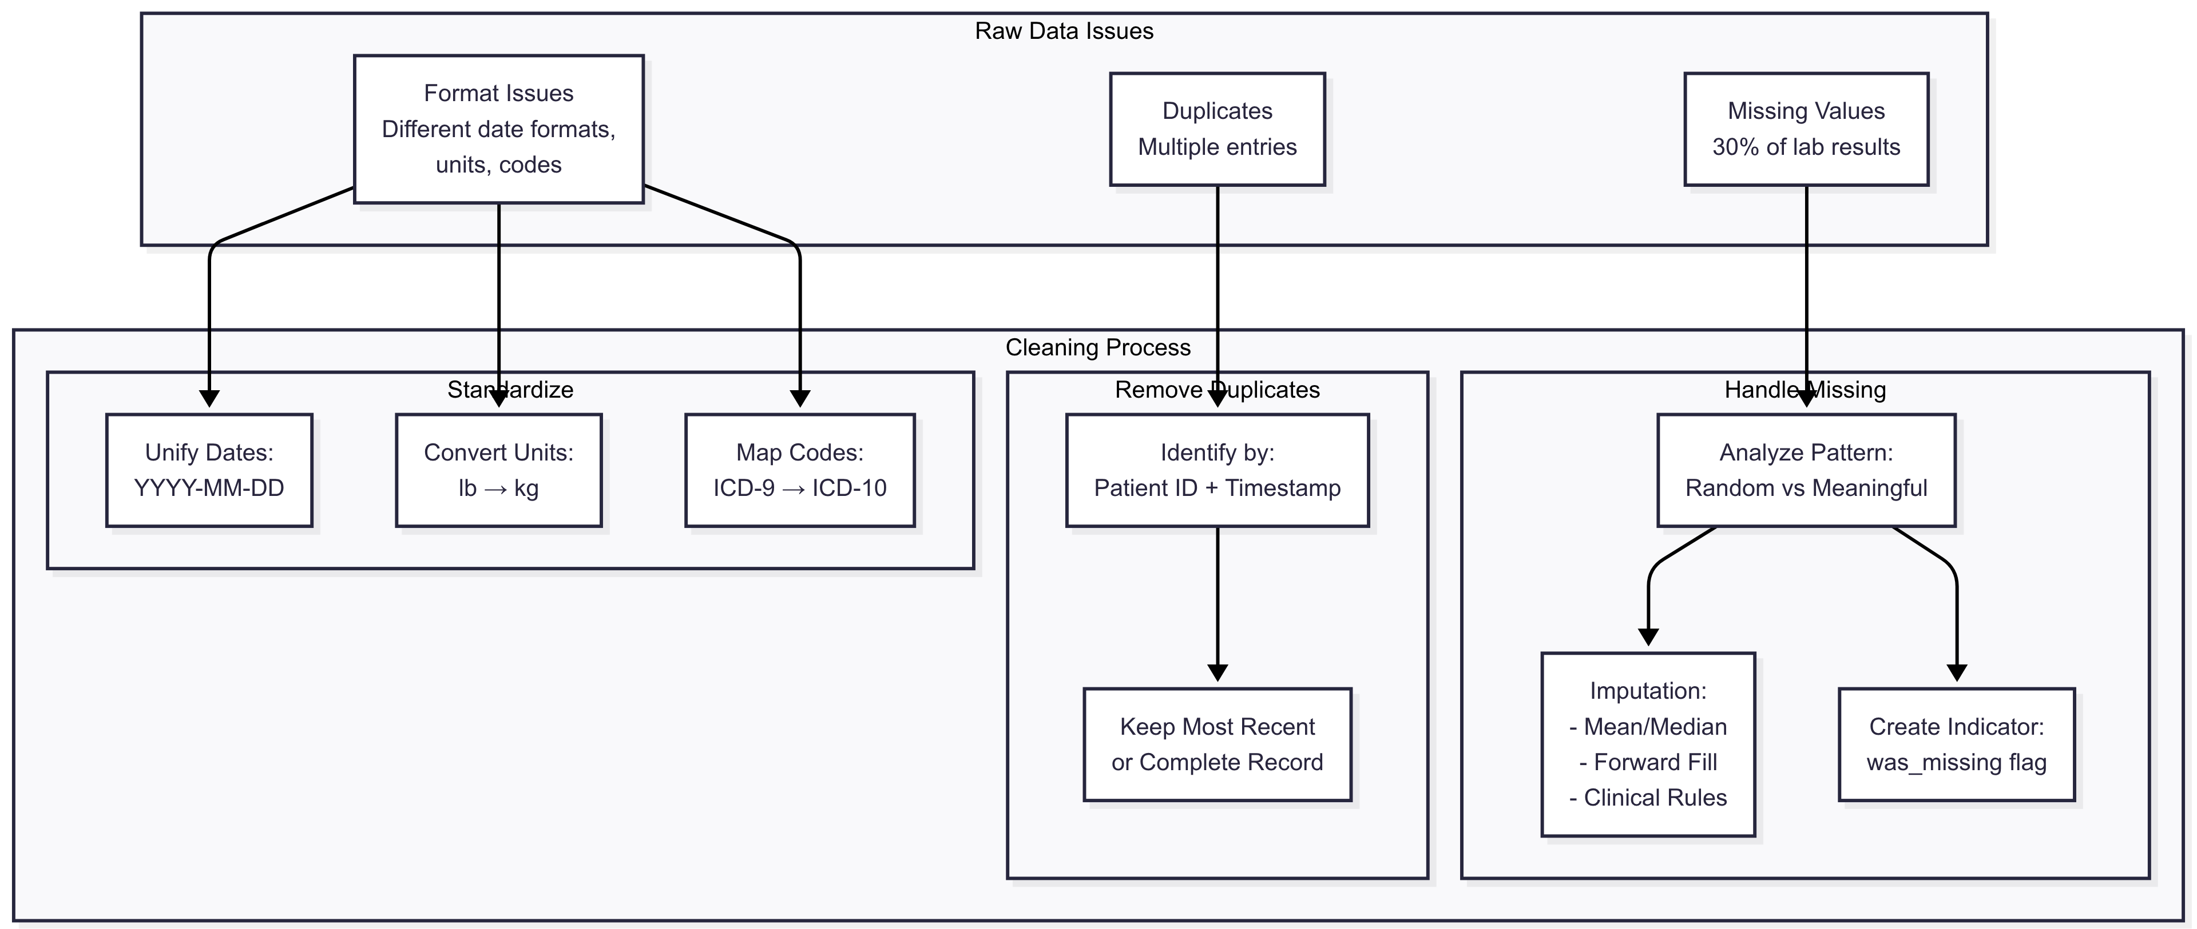

1. **Feature Engineering:** I will transform raw data into clinically meaningful predictors. For example, I will calculate the Charlson Comorbidity Index from diagnosis codes to create a single mortality risk score. I will also engineer features for medication complexity and derive social support indicators from demographic data. Time-based features, like the day of the week of discharge, will also be created.

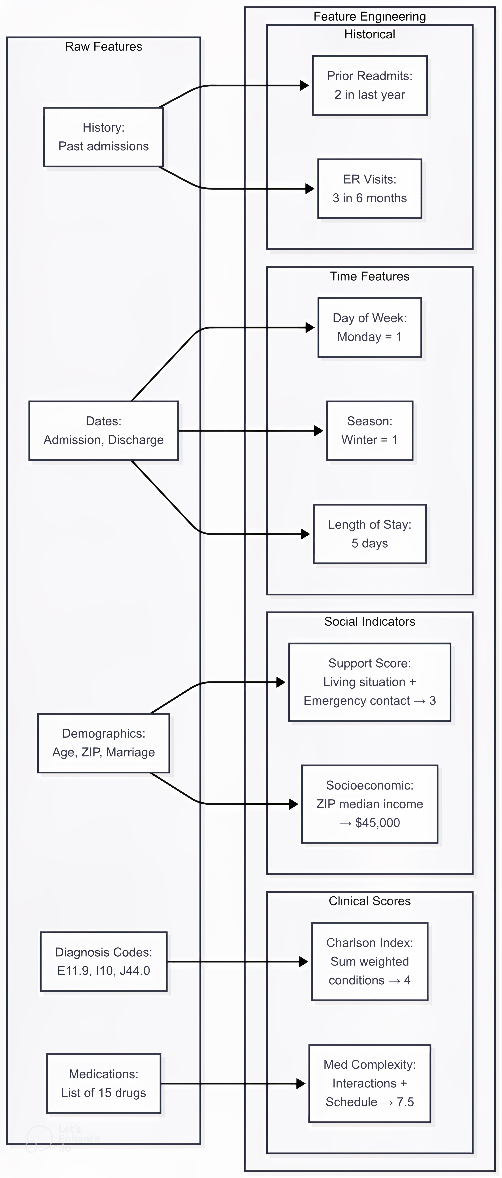

1. **Data Transformation:** The final step is to prepare the engineered features for the model. I will use standard scaling for normally distributed features and min-max scaling for values with known ranges. Categorical features will be one-hot encoded. Crucially, since readmission is a rare event (class imbalance), I will use **SMOTE (Synthetic Minority Over-sampling Technique)** to generate synthetic examples of readmitted patients, creating a balanced dataset for the model to train on.

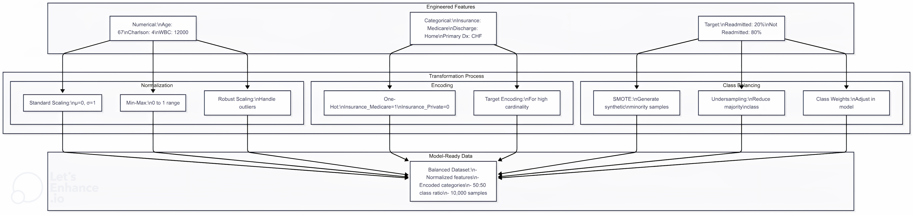

1. **Model Development and Deployment**

For this tabular data problem, I have selected **Gradient Boosting (XGBoost)**. It is well-suited for this task because it handles mixed data types, captures non-linear relationships, has built-in feature importance, and performs exceptionally well with the kind of structured data found in healthcare.

Based on a hypothetical model run with 1,500 patients, the confusion matrix below illustrates potential performance.

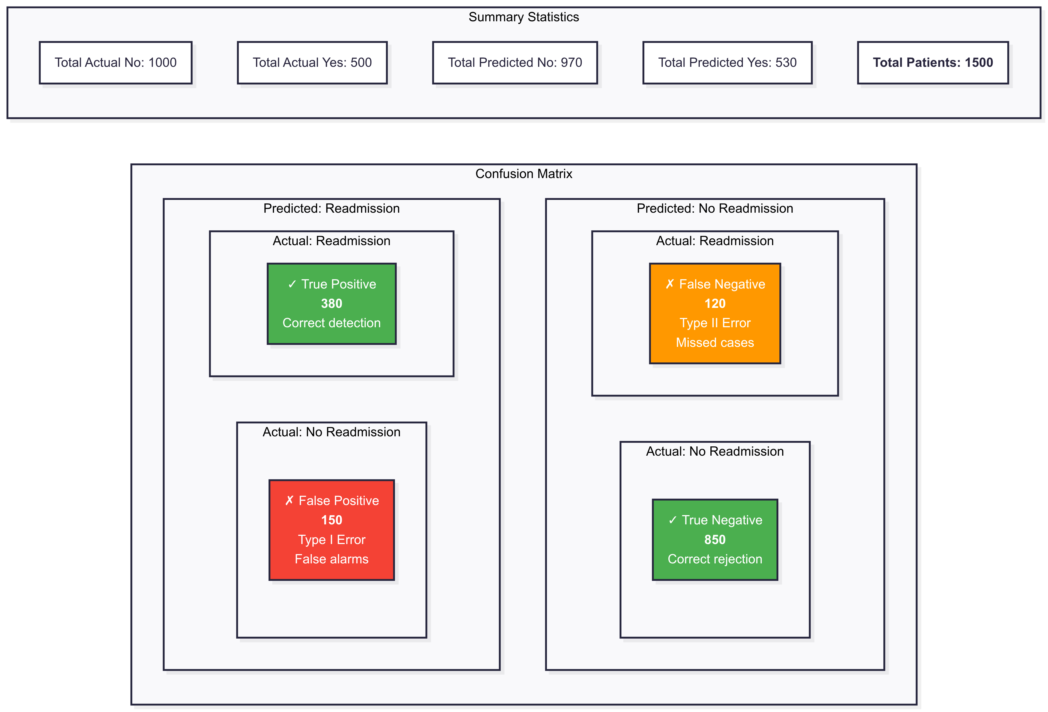

From this, the metrics would be:

* **Precision:** 380 / 530 = 71.7%
* **Recall:** 380 / 500 = 76.0%
* **F1-Score:** 2 * (0.717 * 0.76) / (0.717 + 0.76) = 73.8%

**Deployment Plan:** The integration into the hospital's workflow would involve:

1. **API Development:** Create a RESTful API for model predictions.
2. **EHR Integration:** Embed prediction calls directly into the discharge workflow.
3. **Alert System:** Develop a risk-based alert system for care teams.
4. **Dashboard Creation:** Build a monitoring interface for administrators.
5. **Testing, Training, and Piloting:** Conduct UAT with clinical staff, provide comprehensive training, and launch a pilot program in one department before a hospital-wide rollout.

**HIPAA Compliance:** We will ensure compliance through strict technical and administrative safeguards, including end-to-end data encryption (AES-256), role-based access controls, audit logs, de-identification of data for training, and Business Associate Agreements with all vendors.

**Optimization:** To address overfitting, I will use **regularization (L1/L2) with cross-validation**. Additionally, I will employ techniques like early stopping, limiting tree depth in the XGBoost model, and monitoring validation metrics during training.

### **Part 3:**

### **Critical Analysis and Considerations.**

**Ethics and Bias**

Biased training data can have severe consequences. **Underrepresentation** of certain demographic groups can lead to a model that fails to accurately predict their readmission risk. Furthermore, **historical bias** in care access could mean that marginalized groups who historically had fewer readmissions (due to barriers, not better health) are assigned a lower risk score, preventing them from receiving necessary interventions.

To mitigate this, our strategy includes:

* **Fairness-Aware Sampling:** Ensuring the training data proportionally represents all demographic groups in the hospital's population.
* **Bias Auditing:** Regularly testing model performance across different subgroups.
* **Threshold Adjustment:** Using group-specific decision thresholds to ensure equitable sensitivity across populations.

**Trade-offs**

* **Interpretability vs. Accuracy:** In healthcare, there is a constant trade-off between highly accurate but opaque models (like Deep Neural Networks) and more interpretable models (like Logistic Regression) that clinicians can more easily understand and trust. My recommendation is to use **XGBoost with SHAP (SHapley Additive exPlanations)** values, which strikes a balance by providing high accuracy (80-85%) while offering insights into why a prediction was made.
* **Limited Computational Resources:** If a hospital has limited resources, I would choose lighter models like Random Forest over Deep Learning, implement batch predictions instead of real-time, use cloud services for training, and employ techniques like feature selection and model compression to reduce the computational load.

### **Part 4:**

### **Project Reflection and Workflow.**

**Reflection on Challenges**

The most challenging aspect of developing this hospital readmission system is balancing model performance with healthcare-specific constraints.

* **Data Quality and Integration** is exceptionally difficult. Hospital data is fragmented across multiple systems, and missing data is often clinically significant, making standard imputation problematic.
* **Ethical and Regulatory Compliance** adds another layer of complexity. Every decision must be weighed against HIPAA compliance, patient privacy, and the potential for algorithmic bias, which adds significant time to the development timeline for fairness testing.

+

**How to Improve with More Time/Resources**

With additional resources, I would implement:

1. **Advanced Data Infrastructure:** Invest in a unified data warehouse with real-time streaming to solve data fragmentation and enable more sophisticated feature engineering, potentially improving accuracy by 10-15% by incorporating NLP on clinical notes.
2. **Ensemble Approach with Interpretability:** Develop a multi-model ensemble that combines deep learning, traditional ML, and rule-based systems, with a meta-model that learns when to trust each component. This would address the accuracy-interpretability trade-off more elegantly.



1. **Continuous Learning Framework:** Implement an automated retraining pipeline that detects model drift in real-time and triggers retraining when performance degrades.
2. **Enhanced Fairness and Bias Mitigation:** Create a dedicated fairness team to implement continuous bias monitoring, automated alerts, and regular audits by external ethics committees.

### **Complete AI Development Workflow Breakdown.**

The following diagrams illustrate the comprehensive, multi-stage workflow required for developing and deploying a successful AI system in a clinical environment.

**1. Discovery and Planning Phase (2-3 weeks)** This foundational phase establishes the clinical context and operational constraints. It involves stakeholder interviews, current state analysis, and requirements gathering, leading to a detailed project plan.



**2. Data Acquisition and Preparation Phase (6-8 weeks)** This is the most time-intensive early stage, often requiring IRB (Institutional Review Board) approval. It includes data collection, cleaning, integration, and feature engineering.

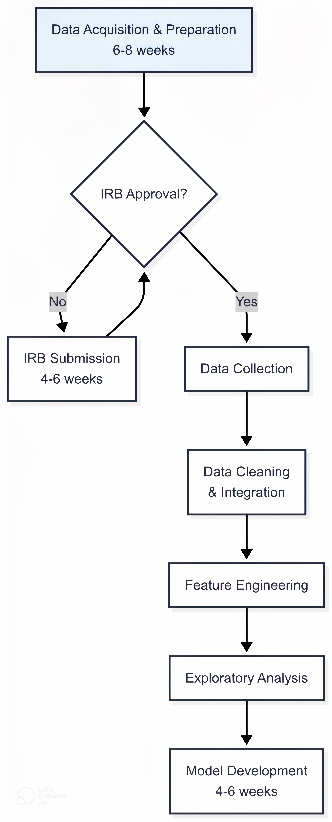

**3. Model Development Phase (4-6 weeks)** This phase employs an iterative approach, starting with baseline models to establish benchmarks and moving to advanced models. It involves extensive hyperparameter tuning and cross-validation.

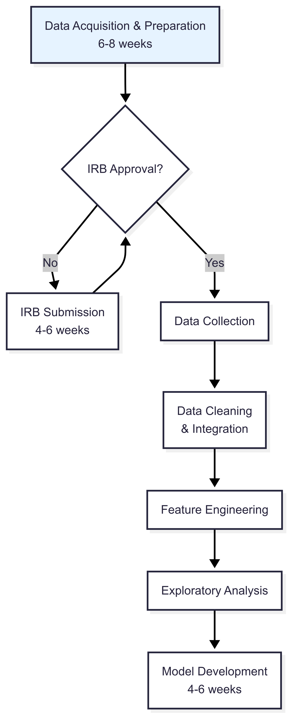

**4. Validation and Integration Phase (3-4 weeks)** This phase distinguishes healthcare AI, requiring rigorous clinical validation. It involves expert review by clinicians, case studies, and extensive bias testing before moving to system integration.

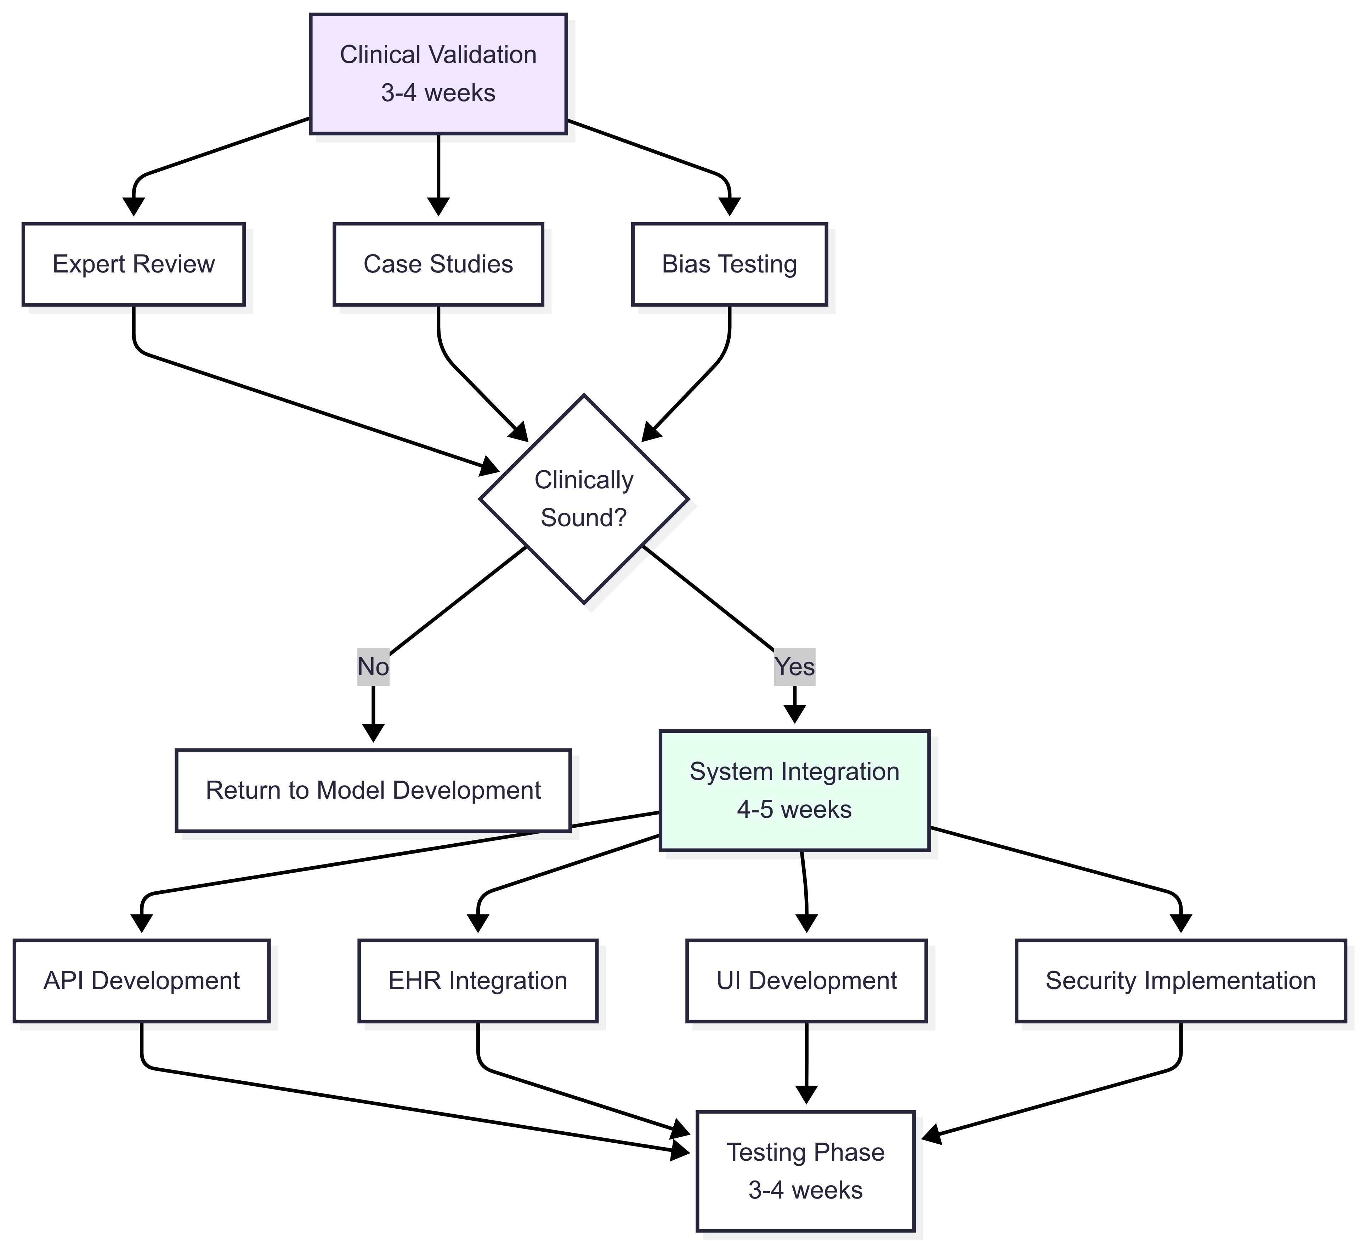

**5. Deployment and Monitoring Phase (4-6 weeks)** The final stage ensures safe and effective deployment through careful testing and a phased rollout, starting with a pilot. Production monitoring is a continuous process, creating a feedback loop for ongoing model improvement.

